Getting Started at Palomar
Apply for Admission Class Schedule Register for Classes Academic Calendar College Catalog Financial Aid/Scholarships General Information about Palomar College

Class Schedule

Spring 2010
Registration still available for late start classes; Fast Track II classes began March 29.

Summer 2010
Summer 2010 classes begin June 21. Registration will begin on
April 6.
View Class Schedule | Register

About Palomar College
Palomar College is a public two-year community college. The Palomar campus is located in San Marcos, California, approximately 30 miles north of San Diego. Palomar enrolls approximately 30,000 full-time and part-time students. Residents of California are charged only $26 per unit. At Palomar, students may choose from over 200 associate degree and certificate programs, complete the first two years of a bachelor's degree, or enjoy personal enrichment classes

Administration of Justice
American Indian Studies
American Sign Language
Art
Behavioral Sciences
Business education
Chemistry
Child Development
Communications
Computer Science and
Information Systems
Cooperative Education
Counseling
Dental Assisting
Earth Sciences
Economics, History & Political Science
Emergency Medical Education (cấp cứu nội khoa)
English
English as a Second Language
Environmental Technology
Family and Consumer Sciences
Fire Technology
Foreign Languages
Graphic Communications
Journalism
Mathematics
Multicultural Studies
Nursing Education
Performing Arts
Physical Education
Physics and Engineering
Public Safety
Regional Occupational Program
Reading Sciences
Special Education
Speech Communications
Trade and Industry
Water Technology
Welding
Zoology
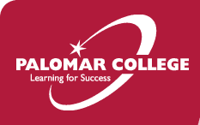 | 

Fact Sheet
The Best of Locations
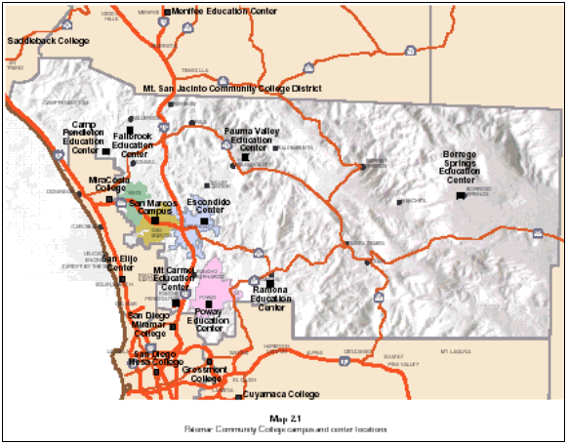
Palomar College is one of 108 colleges in the California Community Colleges system and eight in San Diego County. Located in San Marcos, California, our 200-acre main campus is nestled at the foot of the region’s rolling coastal hills and valleys in a lovely area once named Los Vallecitos de San Marcos (Little Valleys of St. Mark) by Spaniard settlers in 1797. San Marcos is perfectly situated just 30 miles north of San Diego, 90 miles south of Los Angeles, 12 miles east of Southern California’s serene beaches, and a two-hour drive from the Laguna Mountains and the Anza Borrego Desert State Park. In addition to our main campus in San Marcos, we operate an educational center in Escondido, and seven smaller centers throughout north San Diego County, in Rancho Penasquitos, Poway, Fallbrook, Ramona, Pauma Valley, Borrego Springs, and Camp Pendleton. (Click here for detailed maps and driving directions.)
The Students We Serve
Palomar College serves more than 30,000 full-time and part-time students each fall and spring semester, while about 18,000 students attend during summer semester. About 25 percent of our students are enrolled full-time, while about 60 percent are enrolled part-time in credit classes, and 15 percent are enrolled in non-credit classes. About half of our students are aged 18 through 24, while the other half are 24 through 60+. A majority of Palomar students are employed. Our student population is nicely diverse in its ethnicity, with about one-fourth Hispanic, about 6 percent Asian, about 4 percent African-American, and smaller populations of Filipino and Native American. Another 10 percent of our students have not indicated their ethnicity. We typically serve about 300 international students from 49 different countries each semester as well. These students must achieve a minimum score of 470 on the Test of English as a Foreign Language and carry an F-1 student visa.
Our Academic Program Offerings
Palomar College offers more than 300 Associates Degree and certificate programs, as well as not-for-credit community development and personal enrichment classes for life-long learning. We have transfer agreements with the California State University and University of California systems, and our high-level coursework in transferable classes fully prepares our students for success at four-year colleges and universities. In fact, Palomar students who transfer perform better in their first year at a four-year college than students from other community colleges. Our five academic divisions are: Arts, Media, Business and Computer Systems; Career, Technical and Extended Education; Languages and Literature; Mathematics and The Natural and Health Sciences; and Social and Behavioral Sciences. Instructional departments are:
Administration of Justice  American Indian Studies  American Sign Language  Art  Behavioral Sciences  Business education  Chemistry  Child Development  Communications  Computer Science and  Information Systems  Cooperative Education  Counseling  Dental Assisting | Earth Sciences  Economics, History & Political Science  Emergency Medical Education  English  English as a Second Language  Environmental Technology  Family and Consumer Sciences  Fire Technology  Foreign Languages  Graphic Communications  Journalism  Mathematics  Multicultural Studies | Nursing Education  Performing Arts  Physical Education  Physics and Engineering  Public Safety  Regional Occupational Program  Reading Sciences  Special Education  Speech Communications  Trade and Industry  Water Technology  Welding  Zoology
Culture and Community
Palomar College serves as a cultural hub of north San Diego County. Our 400-seat Howard Brubeck Theatre is the scene of highly-regarded dramatic, dance, and musical productions throughout the year. The Boehm Art Gallery has gained a national reputation as a fine contemporary visual art space and offers free art exhibitions by internationally renowned artists as well as locals. Palomar College hosts the only planetarium in north San Diego County and offers weekly planetarium shows for the community. Our five-acre arboretum is home to hundreds of native plant species enjoyed by staff, students and community members. And for the sports fan, Palomar offers a full range of men’s and women’s athletic teams, which consistently win regional, state, and national recognition for excellence.
Affordable Education
The California Community College system offers the most affordable education among community colleges through the United States. California residents pay an enrollment fee of only $20 per credit. Out-of-state residents pay the enrollment fee plus tuition fees of $179 per credit. Financial Aid from the federal and state governments, Palomar College and private sources is available to assist students with the costs of attending college. Aid comes in the form of grants, student loans and work-study opportunities. We encourage all students to apply for financial aid, regardless of ability to pay.
Athletics
Palomar College has nearly two dozen athletic teams in about one dozen sports, including men’s and women’s basketball, volleyball, tennis, soccer, swimming, water polo, and cross country. The College also competes against other colleges in football, baseball, softball, golf, and wrestling. Admission is free to all home athletic events held during the day, and students can attend evening competitions free with their Palomar Identification Cards. Palomar’s athletic teams consistently win regional, state, and national recognition for excellence.
© 2010 Palomar Community College District. All rights reserved. Contact Information. Legal Notices.
Last modified.
Palomar Community College District 1140 West Mission Road, San Marcos, CA 92069 Tel: 760-744-1150

